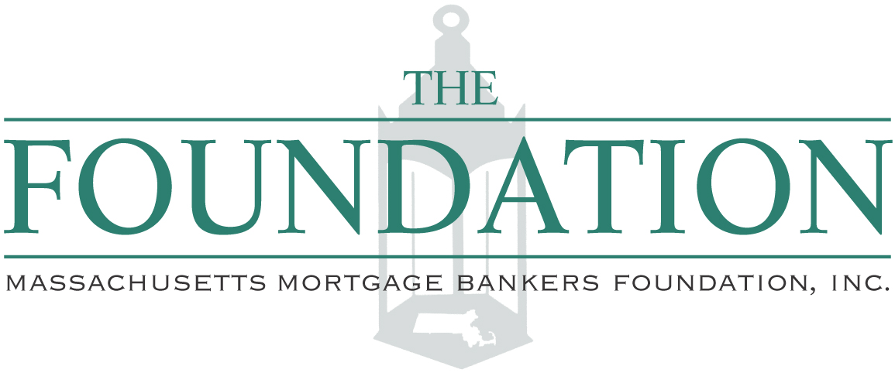

FUNDING REQUEST APPLICATION (page 1)

Legal Name of Organization | Name of Executive Director
Address

Contact | Title
Phone  ( ) | Total Number of Board Members
Fax  ( ) | Total Number of Staff Full Time Part Time
E-Mail | Total Number of Volunteers
Total Annual Organization Budget $  Fiscal Year End | What % of donations is going to the charitable purpose (after expenses):
1) Summarize Your Organization’s Mission:
THE FOUNDATION WAS ORGANIZED FOR THE PURPOSE OF PROVIDING GRANTS THAT WOULD BE UTILIZED TOWARDS THE DEVELOPMENT OF EDUCATION AND PROMOTION OF AFFORDABLE HOUSING WITHIN THE COMMONWEALTH OF MASSACHUSETTS. PLEASE BE SPECIFIC REGARDING WHAT YOU ARE INTENDING TO USE THESE FUNDS FOR.

About Your Request
Amount Requested $

Funds will be used for: □ Operating Budget □ Program □ Project □ Event □ Other

Purpose of Grant: □ Education/Literacy □ Housing Development (check one)

2) Description of Funding Request:
List the Target Population, Constituents, and Geographic Communities that will Benefit from this request:
Name of Event, if applicable: | Date of Event:
MMBA Member Referral (Name/Company):
Contact Information (Phone/Email)

FUNDING REQUEST APPLICATION (page 2)

Besides the MMB Foundation grant application, please also provide us with the following documentation:

- Letter of recommendation from a member of the MMBA
- Copy of your 501 (c)(3) status
- Information regarding your organization that may be helpful to understand your mission and goals
- List of current Board of Directors
- Most recent financial statements

Application and supporting documentation can be emailed to: grants@massmba.com

